Software Requirements Specification

for

BOOK STORE

**Version 1.0 approved**

**Prepared by Duy Nguyen Hoang &  
Han Duong Hai &  
Binh Nguyen Son &  
Anh Nguyen Tien**

**University of Information Technology - VNUHCM**

**Last modified date: 24/10/2024**

**Table of Contents**

1. Introduction 1

1.1 Document Purpose 1

1.2 Document Conventions 2

1.3 Project Scope 2

1.3.1 Key Objectives: 2

1.3.2 Major Features in This Release (Version 1.0): 3

1.3.3 Long-Term Vision: 3

1.4 References 4

2. Overall Description 4

2.1 Product Perspective 4

2.2 User Classes and Characteristics 4

2.3 Operating Environment 5

2.4 Design and Implementation Constraints 5

2.5 Assumptions and Dependencies 5

2.5.1 Assumption 5

2.5.2 Dependencies 6

3. System Feature 7

3.1 Account Management 8

3.2 Employee Management 9

3.3 Financial Management 9

3.4 Import Order Management 10

3.5 Invoice Management 11

3.6 Book Management 11

3.7 Customer Services 12

3.8 Customer Management 12

4. Data Requirements 13

4.1 Logical Data Model 13

4.1.1 Business Model 13

4.1.2 Data Objects and Attributes 13

4.1.3 Data Relationships 14

4.2 Data Dictionary 14

4.2.1 User Management Data 14

4.2.2 Customer Management Data 15

4.2.3 Book Management Data 15

4.2.4 Order and Payment Data 16

4.2.5 Staff and Shift Management Data 16

4.2.6 Revenue Management Data 16

4.2.7 Feedback and Messaging Data 17

4.3 Reports 17

4.4 Data Acquisition, Integrity, Retention, and Disposal 18

5. External Interface Requirements 18

5.1 User Interfaces 18

5.1.1 Overview 18

5.1.2 Sitemap 19

5.2 Software Interfaces 21

5.3 Hardware Interfaces 22

5.4 Communications Interfaces 22

6. Quality Attributes 22

6.1 Usability 22

6.2 Performance 23

6.3 Security 24

6.4 Safety 24

6.5 Additional Quality Attributes 24

7. Internationalization and Localization Requirements 25

7.1 Currency 25

7.2 Date and Time Formatting 25

7.3 Number Formatting 25

7.4 Language Support 26

7.5 Address and Phone Formatting 26

7.6 Compliance with Local Laws 26

7.7 Cultural Sensitivity 26

7.8 Paper Sizes and Units 26

7.9 Electrical Standards 26

8. Other Requirements 27

9. Glossary 27

10. External Interface Requirements 29

10.1 Data Flow Diagram 29

10.1.1 Level 0 DFD 29

10.1.2 Level 1 DFD 29

10.2 Feature Tree 31

10.3 State Transition Diagram 33

10.3.1 Order Management 33

10.3.2 User Management 34

10.4 Entity Relationship Diagrams (ERD) 34

**Revision History**

|  |  |  |  |
| --- | --- | --- | --- |
| **Name** | **Date** | **Reason For Changes** | **Version** |
| Initial | 24/10/2024 | The first version of SRS | 1.0.0 |
|  |  |  |  |

# Introduction

## Document Purpose

This document describes the software requirements for the Online Bookstore Management System (BookStore). The system is designed to optimize the business processes of the bookstore, including inventory management, sales monitoring, order management, and customer interaction. The main objective of the system is to provide a convenient book shopping experience for customers while reducing the workload for the bookstore staff and owners.

This document serves the stakeholders as follows:

* **Developers:** To clearly understand functional and non-functional requirements, ensuring that system development aligns with the set objectives.
* **Project Management:** To track progress, manage timelines, and ensure that the final product meets the specified requirements.
* **Users:**
  + **Admin:** Manages the system, including books, staff, customers, and transactions.
  + **Staff:** Manages invoices, books, inventory, and customer service.
  + **Customers:** Browse books, place orders, make payments, and participate in promotional programs.
* **Testers:** Design and test to ensure the system operates according to the functional requirements and desired performance.
* **Documentation Writers:** To create user guides, technical manuals, and other relevant documents that will support the training and onboarding of end users. This document will serve as the foundational reference for preparing the necessary documentation for all user types.

This document ensures that all relevant stakeholders have a clear understanding of the system's objectives, functionalities, and expectations, providing a structured roadmap for both the development and deployment phases.

## Document Conventions

This document adheres to the IEEE SRS standard.

Symbols used in the document:

* FR: Functional Requirement
* NFR: Non-functional Requirement

## Project Scope

The BookStore Management System project aims to develop a comprehensive bookstore management system that serves both business needs and customer experiences. The system will provide an e-commerce platform combined with internal management tools to ensure process optimization and enhanced customer service quality.

* For Customers: Customers can search for books, make purchases, pay online, and contact support staff through a real-time chatbox.
* For Staff and Admin: The system provides tools to manage inventory, invoices, customers, finances, and human resources, helping streamline daily operations and minimize manual errors.
* Real-time Connectivity: The system uses WebSocket for the chat feature to improve interaction between customers and staff, enhancing customer support efficiency.

### Key Objectives:

* Efficiency and Automation
  + Automate processes such as inventory management, order processing, invoicing, and payroll to reduce manual errors.
  + Provide real-time reports on financials, sales, and inventory, enabling staff and managers to make quick decisions.
  + Employee schedule management: Admins can easily assign shifts and monitor employee performance.
* Improved Customer Experience
  + Easy ordering and payment: Customers can search for books, add them to their cart, and complete payments quickly with multiple payment methods (COD, credit card, e-wallet).
  + Real-time order updates: Users can track their order status through automated notifications.
  + Real-time support chatbox: Staff can respond to customer queries immediately via WebSocket, improving customer satisfaction.
  + Smart recommendations: Based on shopping history, the system suggests books that match customers' interests.
* Data-Driven Decision Making
  + Detailed analytics and reporting: Provide daily, monthly, and yearly charts and reports to monitor revenue and inventory.
  + Customer data analysis: Store and analyze customer interactions to create targeted marketing campaigns and promotions.

### Major Features in This Release (Version 1.0):

* **User Login and Role Management:**
  + Clear role-based permissions for admin, staff, and customers to ensure data security.
  + Customers and staff have separate accounts to access and perform relevant functions.
* **Product Management:**
  + Admins can add, edit, and update book information (title, author, category, price, and quantity).
  + Customers can search for books, view details, and leave reviews.
* **Invoice and Order Management:**
  + Admins and staff can confirm, modify, and view detailed invoices.
  + Customers can track their orders and check payment status.
* **Support for Multiple Payment Methods:** Payment options include credit cards, e-wallets, and COD, providing users with flexibility.
* **Customer Management and Direct Interaction:** Customers can update personal information, view purchase history, and request support through the chatbox.
* **Real-time Chatbox:** The WebSocket-powered system allows instant communication between customers and staff, enhancing customer satisfaction and improving service efficiency.

### Long-Term Vision:

In the future, the Book Store System will continue to evolve with new features and upgrades to meet the expanding needs of businesses and customers:

1. **Enhanced Security:**

* Register for an SSL certificate to support HTTPS, securing all online transactions.
* Strengthen WebSocket security against attacks such as XSS and DDoS.

1. **Improved User Experience (UI/UX):**

* Update the interface with smooth animations and interactions to enhance the shopping experience.
* Develop a mobile version with a native app, allowing users to shop conveniently on their phones.

1. **Expanded API Integration:**

* Connect with external services such as Google Analytics to monitor traffic and user behavior.
* Integrate with delivery platforms to automate shipping processes and update order statuses.

1. **AI-Powered Recommendations**: Develop AI algorithms to predict customer preferences and provide more accurate product suggestions.
2. **Diversification of Products and Services:**

* Collaborate with more publishers and suppliers to expand the book catalog.
* Launch a VIP membership program with special offers and promotions for loyal customers.

1. **Multilingual and Localization Support:** Expand services to international markets by supporting multiple languages.

## References

* ISO/IEC 9126: Software Engineering - Product Quality
* User Interface Guidelines for Modern Web Applications

# Overall Description

## Product Perspective

The Book Store System operates as an online retail platform that connects customers with book suppliers and manages the entire business process, from product display and inventory management to order processing.

## User Classes and Characteristics

* Admin: Manages employees, customers, books, finances, and invoices.
* Staff: Manages invoices, supports customers, and handles inventory restocking.
* Customer: Browses books, adds them to the cart, makes payments, and leaves reviews.

## Operating Environment

* **Hardware**: Web-based applications running on desktop and mobile devices.
* **Software**: Modern web browsers (Chrome, Firefox, Edge) with backend in Node.js and frontend in React.
* **Database**: PostgreSQL.
* **Operating System**: Windows 11
* **Design and Analysis Tool**: draw.io
* **Application Development Tools:** Visual Studio Code, IntelliJ IDEA 2023.3.4

## Design and Implementation Constraints

* *Regulatory compliance (e.g., GDPR for customer data).*
* *Integration with external payment gateways.*
* *Compatibility with existing hotel management tools.*

## Assumptions and Dependencies

During the development of the BookStore Management System (BMS), assumptions and dependencies have been identified to ensure the project achieves the desired outcomes. These factors must be considered throughout the project lifecycle to ensure its success.

### Assumption

#### User Accessibility to Technology

* Users (administrators, staff, and customers) will have access to devices such as computers, tablets, or smartphones capable of running modern browsers like Chrome, Firefox, or Safari.
* A stable internet connection is required to use online features such as product search, online payments, and chatbox communication.

#### Familiarity with Digital Systems

* Staff and administrators are assumed to have basic knowledge of online management systems and electronic payments, facilitating their use of the system.
* Customers are expected to search, place orders, and complete payments online with minimal guidance.

#### Availability of Third-party Services

* The system will integrate online payment gateways (such as PayPal, Stripe, or Momo) to support various payment methods, including credit cards, e-wallets, and bank transfers.
* ElephantSQL will be used as the database in the deployment environment, with the assumption that it will maintain stability throughout the development and operational phases.
* WebSocket will support real-time chat functionality. It is assumed that no significant disruptions will occur during the connection.

#### Compliance with Legal Regulations

Development will comply with data protection regulations, such as GDPR or equivalent standards. The system must be designed to encrypt data and obtain user consent when collecting personal information.

#### Stakeholder Engagement

* The project depends on timely collaboration and feedback from stakeholders, including admins, staff, and customers, to ensure the system features meet practical needs.
* It is assumed that the integration with payment gateway APIs and third-party services will proceed smoothly, without compatibility issues or service interruptions.

### Dependencies

#### Third-party Components

* The system relies on successful integration with online payment gateways (e.g., Stripe, PayPal, or Momo) to support both online and in-store payments.
* ElephantSQL will serve as the database management platform in the deployment environment, with the project’s success depending on its performance and availability.
* WebSocket will enable real-time chat between staff and customers. Any service disruption or security vulnerability could interrupt this functionality.

#### Regulatory Environment

Data security and electronic transaction regulations may change in the future. Such changes could require system design modifications or additional security features to ensure compliance.

#### User Feedback and Testing

The project’s success depends on timely feedback from admins, staff, and customers during testing phases. Delayed or incomplete feedback may affect project timelines and require adjustments to certain features.

#### Resource Availability

* The project’s success relies on the availability of development and testing teams, including both technical and support personnel. Staff shortages or resource changes may impact on project progress and quality.
* Budget and development timelines are also critical. Adjustments to the budget or deadlines could affect the implementation of features such as SSL registration or UI/UX improvements in future versions.

# System Feature

***Grouped Use Cases by Functionality***

|  |  |
| --- | --- |
| **Functional Group** | **Use Cases** |
| Account Management | Login, Logout, Change password |
| Employee Management | Add/Edit employee information, Add employee schedule, Send consultation messages, Search employees, View employee list/details |
| Financial Management | Add inventory, Process payroll, View financial charts |
| Import Order Management | Add import orders, View/search import orders, View import order details |
| Invoice Management | Confirm invoices, View/search invoices, View invoice list/details |
| Book Management | Add/Edit book information, View book details, View top-selling products, View book reviews |
| Customer Services | Search/filter books, Place orders, Make payments, Send messages, Leave comments, Customer support |
| Customer Management | View customer list/details, View loyal customers, Search customers |

## Account Management

|  |  |
| --- | --- |
| Description | Account management includes basic operations such as logging in, logging out, and changing passwords to ensure user security. |
| Stimulus/Response Sequences | **1. Login:**  - Stimulus: User enters credentials (username, password).  - Response: System verifies and grants access or displays an error message.  **2. Logout:**  - Stimulus: User clicks the logout button.  - Response: System terminates the session and redirects to the login page.  **3. Change Password:**  - Stimulus: User submits the current password and a new password.  - Response: System updates the password or returns an error (e.g., incorrect current password). |
| Functional Requirements | FR1: The system must validate user credentials on login.  FR2: The system must terminate sessions properly upon logout.  FR3: The system must allow users to change passwords only with valid current credentials. |
| Service | Authentication and session management to secure system access. |

## Employee Management

|  |  |
| --- | --- |
| Description | Employee management involves adding and editing employee information, scheduling, sending consultation messages, and searching for employees to ensure smooth operations. |
| Stimulus/Response Sequences | **1. Add Employee:**  - Stimulus: Admin fills out employee details and submits them.  - Response: The system adds employees to the database.  **2. Edit Employee Information:**  Stimulus: Admin selects an employee and modifies their information.  Response: The system updates the employee record.  **3. Search Employees:**  Stimulus: Admin enters search criteria (e.g., name, department).  Response: The system displays matching employees. |
| Functional Requirements | FR1: The system must allow the admin to add new employees.  FR2: The system must allow updating employee information.  FR3: The system must support employee search functionality.  FR4: The system must store and display employee schedules. |
| Service | Managing employee data and schedules for effective organizational control. |

## Financial Management

|  |  |
| --- | --- |
| Description | Financial management involves managing payroll, adding inventory, and tracking finances through charts and reports. |
| Stimulus/Response Sequences | **1. Add Inventory:**  - Stimulus: Admin submits details for new stock.  - Response: The system updates the inventory levels.  **2. Process Payroll:**  - Stimulus: Admin submits payroll details for employees.  - Response: The system processes and records the payroll.  **3. View Financial Charts:**  - Stimulus: Admin selects a date range.  - Response: The system generates and displays financial charts. |
| Functional Requirements | FR1: The system must allow admins to record new inventory.  FR2: The system must process employee payroll accurately.  FR3: The system must generate financial charts by specified time periods. |
| Service | Facilitating stock management and financial reporting. |

## Import Order Management

|  |  |
| --- | --- |
| Description | This functionality covers adding, searching, and viewing details of import orders to manage incoming stock. |
| Stimulus/Response Sequences | **1. Add Import Order:**  - Stimulus: Admin fills out and submits an import order.  - Response: The system records the new order.  **2. Search Import Orders:**  - Stimulus: Admin enters search criteria.  - Response: The system returns matching orders.  **3. View Import Order Details:**  - Stimulus: Admin selects an import order.  - Response: The system shows detailed information. |
| Functional Requirements | FR1: The system must allow admins to add import orders.  FR2: The system must support search functionality for import orders.  FR3: The system must display detailed information about selected import orders. |
| Service | Tracking and managing incoming stock efficiently. |

## Invoice Management

|  |  |
| --- | --- |
| Description | Invoice management includes confirming invoices, searching for invoices, and viewing detailed information for transaction management. |
| Stimulus/Response Sequences | **1. Confirm Invoice:**  - Stimulus: Admin confirms invoice payment.  - Response: The system marks the invoice as paid.  **2. Search Invoices:**  - Stimulus: Admin enters search criteria.  - Response: The system returns matching invoices.  **3. View Invoice Details:**  - Stimulus: Admin selects an invoice.  - Response: The system displays invoice details. |
| Functional Requirements | FR1: The system must allow admins to confirm invoices.  FR2: The system must support invoice search functionality.  FR3: The system must display detailed information for invoices. |
| Service | Managing and tracking financial transactions effectively. |

## Book Management

|  |  |
| --- | --- |
| Description | Book management involves adding and editing book information, viewing book details, and displaying reviews and top-selling products. |
| Stimulus/Response Sequences | **1. Add Book:**  - Stimulus: Admin enters the book details and submits them.  - Response: The system saves the new book.  **2. Edit Book Information:**  - Stimulus: Admin updates information for an existing book.  - Response: The system updates the book details.  **3. View Reviews:**  - Stimulus: User selects a book.  - Response: The system displays the reviews. |
| Functional Requirements | FR1: The system must allow admins to add new books.  FR2: The system must support editing book information.  FR3: The system must display reviews and top-selling books. |
| Service | Managing book catalog and customer feedback. |

## Customer Services

|  |  |
| --- | --- |
| Description | Customer services include placing orders, making payments, searching for books, and communicating with the service team. |
| Stimulus/Response Sequences | **1. Place Order:**  - Stimulus: Customer selects books and confirms the order.  - Response: The system processes the order.  **2. Make Payment:**  - Stimulus: Customer provides payment details.  - Response: The system processes the payment.  **3. Search Books:**  - Stimulus: Customer enters search criteria.  - Response: The system returns matching books. |
| Functional Requirements | FR1: The system must allow customers to place orders.  FR2: The system must securely process payments.  FR3: The system must support book search and filtering. |
| Service | Enhancing customer shopping experience. |

## Customer Management

|  |  |
| --- | --- |
| Description | Customer management covers viewing customer lists, searching for customers, and managing loyal customers. |
| Stimulus/Response Sequences | **1. View Customer List:**  - Stimulus: Admin selects to view all customers.  - Response: The system displays the customer list.  **2. Search Customers:**  - Stimulus: Admin enters search criteria.  - Response: The system returns matching customers.  **3. View Customer Details:**  - Stimulus: Admin selects a customer.  - Response: The system shows customer details. |
| Functional Requirements | FR1: The system must allow viewing of the customer list.  FR2: The system must support customer search functionality.  FR3: The system must display detailed customer information. |
| Service | Managing customer relationships and loyalty programs. |

# Data Requirements

## Logical Data Model

### Business Model

The system's core business model revolves around:

* Managing Users with different roles (admin, staff, customer).
* Managing Books with attributes like author, language, category, and publisher.
* Handling Orders and their corresponding invoices.
* Tracking Revenue by month and year.
* Managing Staff schedules and shifts.
* Administering Import transactions and book stock.
* Facilitating communication through messages and collecting feedback from users.

### Data Objects and Attributes

1. User

* Represents all users interacting with the system.
* Attributes: user_id, username, password, token, create_at, update_at, role.

1. Staff Information

* Stores personal and employment data of staff members.
* Attributes: staff_id, fullname, email, gender, salary, address, phone_number.

1. Customer Information

* Represents customers who make orders and interact with the system.
* Attributes: customer_id, fullname, email, phone_number, address, loyalty_points.

1. Book

* Stores information about books in the inventory.
* Attributes: book_id, title, price, quantity, author_id, category_id, publisher_id.

1. Order

* Represents transactions made by customers.
* Attributes: order_id, customer_id, order_date, status, total_price.

1. Invoice and Payment

* Records payment transactions and payment methods.
* Attributes: payment_id, customer_id, amount, payment_status.

1. Staff Shift and Schedule

* Records shifts and working schedules for staff.
* Attributes: shift_id, staff_id, start_time, end_time.

1. Revenue Tracking

* Tracks monthly and yearly revenue.
* Attributes: month, total_sale, total_import.

### Data Relationships

* One-to-One: Each user can have one corresponding role in the user_role table.
* One-to-Many: A customer can place multiple orders.
* Many-to-One: Multiple books can belong to one category or one publisher.
* Many-to-Many: A book can have multiple authors through the book_author table.

## Data Dictionary

This section breaks down the data structures used by the system, listing their attributes, types, and descriptions for each relevant entity. Below is a structured format organized by key data objects.

### User Management Data

This section defines the data related to users, staff, roles, and permissions.

|  |  |  |
| --- | --- | --- |
| **Field Name** | **Data Type** | **Description** |
| user_id | SERIAL | Unique identifier for each user |
| username | VARCHAR (50) | Username used for login |
| password | VARCHAR (255) | Encrypted password |
| token | VARCHAR (100) | Token for session management (optional) |
| role_id | INT | Role assigned to the user (admin, staff) |
| create_at | TIMESTAMP | Date the user was created |
| update_at | TIMESTAMP | Date the user was last updated |

***\*Roles and Permissions:***

|  |  |  |
| --- | --- | --- |
| **Field Name** | **Data Type** | **Description** |
| role_id | SERIAL | Unique identifier for each role |
| rolename | VARCHAR (50) | Name of the role (e.g., admin, customer) |
| permission_id | VARCHAR (50) | Permission associated with the role |

### Customer Management Data

This section defines the attributes related to customers and their activities.

|  |  |  |
| --- | --- | --- |
| **Field Name** | **Data Type** | **Description** |
| customer_id | SERIAL | Unique ID for each customer |
| fullname | VARCHAR (100) | Customer’s full name |
| email | VARCHAR (50) | Customer’s email address |
| phone_number | VARCHAR (20) | Contact number of the customer |
| address | VARCHAR (255) | Physical address |
| loyalty_points | INT | Loyalty points collected by the customer |

### Book Management Data

This section contains attributes related to books, authors, categories, and publishers.

|  |  |  |
| --- | --- | --- |
| **Field Name** | **Data Type** | **Description** |
| book_id | SERIAL | Unique identifier for each book |
| title | VARCHAR (250) | Title of the book |
| author_id | INT | Reference to the author of the book |
| category_id | INT | Category to which the book belongs |
| publisher_id | INT | Publisher of the book |
| price | FLOAT | Price of the book |
| quantity | INT | Available stock quantity |
| discount | FLOAT | Discount percentage on the book |
| publication_date | TIMESTAMP | Date the book was published |

***\*Book Relationships:***

|  |  |  |
| --- | --- | --- |
| **Field Name** | **Data Type** | **Description** |
| author_name | VARCHAR (100) | Name of the author |
| category_name | VARCHAR (50) | Name of the category |
| publisher_name | VARCHAR (100) | Name of the publisher |

### Order and Payment Data

Defines the structure for customer orders and payments.

|  |  |  |
| --- | --- | --- |
| **Field Name** | **Data Type** | **Description** |
| order_id | SERIAL | Unique identifier for each order |
| customer_id | INT | Reference to the customer who placed the order |
| order_date | TIMESTAMP | Date and time the order was placed |
| status | BOOLEAN | Status of the order (e.g., pending, completed) |
| total_price | FLOAT | Total price of the order |

***\*Payment Information:***

|  |  |  |
| --- | --- | --- |
| **Field Name** | **Data Type** | **Description** |
| payment_id | SERIAL | Unique identifier for each payment |
| customer_id | INT | Reference to the customer making the payment |
| method_payment | VARCHAR (50) | Payment method (e.g., credit card, cash) |
| payment_status | BOOLEAN | Payment status (completed/pending) |

### Staff and Shift Management Data

This section includes information about staff schedules and shifts.

|  |  |  |
| --- | --- | --- |
| **Field Name** | **Data Type** | **Description** |
| staff_id | SERIAL | Unique ID for each staff member |
| fullname | VARCHAR (100) | Full name of the staff |
| salary | FLOAT | Salary of the staff member |
| shift_id | SERIAL | Unique identifier for each shift |
| start_time | TIMESTAMP | Shift start time |
| end_time | TIMESTAMP | Shift end time |

### Revenue Management Data

This section tracks revenue by day, month, and year.

|  |  |  |
| --- | --- | --- |
| **Field Name** | **Data Type** | **Description** |
| day | INT | Day of the month |
| month | INT | Month of the year |
| year | INT | Year of revenue |
| total_sale | BIGINT | Total sales for the given period |
| total_import | BIGINT | Total imports for the given period |
| revenue | BIGINT | Net revenue |

### Feedback and Messaging Data

This section contains data for feedback and messages exchanged in the system.

|  |  |  |
| --- | --- | --- |
| **Field Name** | **Data Type** | **Description** |
| feedback_id | SERIAL | Unique identifier for feedback entries |
| feedback_comment | TEXT | Feedback or comment from the user |
| rating | INT | Rating score provided by the user |
| message_id | SERIAL | Unique identifier for each message |
| message_content | TEXT | Content of the message |
| message_status | BOOLEAN | Status of the message (read/unread) |

## Reports

The system provides the following reports to help with business operations:

1. Revenue Report: Provides monthly and yearly summaries of total revenue from sales and imports.
2. Staff Performance Report: Tracks shifts and evaluates staff based on feedback and performance metrics.
3. Customer Feedback Report: Aggregates customer reviews and feedback to improve product offerings and services.
4. Inventory Report: Monitors stock levels and alerts when restocking is required.
5. Order Summary Report: Summarizes orders by customer, status, and date for better tracking.

Reports can be exported in PDF or Excel formats for easy sharing.

## Data Acquisition, Integrity, Retention, and Disposal

The system will handle data acquisition and retention through the following mechanisms:

**Data Acquisition**:

* User and book data are collected through input forms.
* Validations are performed on entries to ensure correct formats (e.g., email validation).

**Data Integrity**:

* The system ensures consistency through regular backups and data validation checkpoints.
* Transactions are atomic, ensuring that no data is lost in case of system crashes.

**Data Retention and Disposal**:

* Daily backups are created and retained for 6 months.
* After 6 months, old backups are deleted to maintain storage efficiency.
* Deleted records are fully erased, leaving no traces in the system.

# External Interface Requirements

## User Interfaces

### Overview

The user interfaces (UI) will be designed to provide consistent and intuitive experience for all system users. Key features include:

* **Navigation**: Simple and intuitive navigation with a dashboard for quick access to critical tasks (e.g., room management, booking, payments).
* **Forms**: Input validation for all forms (e.g., booking forms, customer details) to prevent errors.
* **Standard Buttons and Shortcuts**: Common buttons such as "Submit," "Cancel," and "Help" will be used. Keyboard shortcuts will be implemented for frequently used actions (e.g., Ctrl+S for saving).
* **Error Messages**: User-friendly error messages will guide users to resolve common issues (e.g., missing required fields).

UI design will follow modern web standards, ensuring mobile responsiveness and accessibility according to **WCAG 2.1** guidelines.

### Sitemap

#### Customer Portal

* Dashboard: When users successfully log in, they are redirected to the dashboard. Here, users can quickly view notifications about orders and update their personal information.
* Browse Books:
  + Book Categories: Users can browse through categorized book sections such as fiction, science, comics, etc.
  + Search and Filter: Users can search by book title, author, genre, or price.
  + Book Details: When selecting a book, the details page will display the description, reviews, and ratings.
* Shopping Cart:
  + View Cart: Users can view the list of products added to the cart.
  + Update Quantity: Users can change the quantity or remove products from the cart.
  + Checkout: Users can choose a payment method such as credit card, e-wallet, or cash on delivery (COD).
* Order Management:
  + View Orders: Users can view their order history and status (processing, delivered, canceled).
  + Order Details: Displays the details of the order and allows users to track the delivery process.
* Profile Management:
  + Edit Information: Users can update their personal profiles, shipping addresses, and passwords.
  + Order History: View the list of previously purchased orders.
* Review & Feedback:
  + Write Reviews: Users can rate purchased books and share their experiences.
  + View Reviews: Users can see reviews from other customers about books they are interested in.
* Chatbox Support:
  + Direct Support: Customers can send messages to support staff and receive real-time responses via WebSocket.

#### Admin Portal

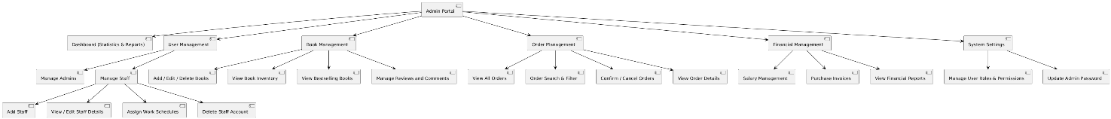

* Dashboard: Statistics and Reporting: Displays revenue charts, inventory reports, and order quantities over time.
* User Management - Admin and Staff Management:
  + Add, edit, or delete staff members.
  + Assign work schedules for each staff member.
  + Grant access rights and edit account information.
* Book Management:
  + Add/Edit/Delete Books: Admin can manage the book inventory, including checking stock levels and identifying bestsellers.
  + Review Management: Admin can approve, delete, or edit user reviews.
* Order Management:
  + View all orders.
  + Search and filter orders by status.
  + Confirm or cancel orders.
* Financial Management
  + Payroll Management: Admin processes salary payments for staff.
  + Invoice Management: Check purchase orders and inventory levels.
  + Financial Reporting: View daily, monthly, or yearly revenue reports.
* System Settings:
  + Role Management: Admin assigns roles to different accounts.
  + Password Update: Change the password for the admin account.

#### Staff Portal

* Dashboard:
  + Work Schedule: Employees can view their work schedules and the assigned orders.
* Book Management:
  + Manage Books: Employees can add or edit books in the inventory.
  + Inventory Tracking: Update stock levels to ensure there are no shortages.
* Order Management:
  + Order Processing: Employees can view the orders assigned to them and confirm or process them.
* Customer Management:
  + View Customer List: Employees can check loyal customers and manage their information.
* Profile Management:
  + Edit Profile: Employees can update their personal information and change their passwords.
* Chatbox Support:
  + Customer Support: Employees interact directly with customers through the chatbox.

#### Public Pages

* About Us: Displays an introduction to the store and the company’s vision.
* Contact Us: Shows the contact address, email, and phone number of the store.
* FAQs: Answers frequently asked questions about products and services.
* Promotions & Events: Promotes promotional programs and special events.
* Terms & Conditions / Privacy Policy: Displays the terms of use and privacy policy so that users are aware of their rights and obligations.

## Software Interfaces

The system will integrate with several external software components:

* **Payment Gateway**: Integration with third-party payment processors (e.g., Stripe, PayPal) via **RESTful APIs** to handle online transactions.
  + Data Format: JSON
  + Communication: Secure with **HTTPS**, using encryption.
* **Email Server**: Integration with external email services (e.g., SendGrid) for sending booking confirmations, invoices, and marketing emails.
  + Data Format: MIME/SMTP
  + Communication: Secure with **TLS/SSL**.
* **Database**: MySQL/PostgreSQL for managing system data. Queries and transactions between the application and database must be optimized for performance.
  + Data Format: SQL
  + Communication: Secure with **SSL**.

## Hardware Interfaces

This system will not be connected with any hardware.

## Communications Interfaces

The system will support various communication interfaces to ensure smooth operation:

* **Email Communication**: Automated emails for booking confirmations, invoices, and customer feedback forms. Attachments (e.g., receipts) must be supported.
  + Formatting: HTML for email body, PDF for attachments.
  + Security: Emails will be sent using secure **SMTP** with **TLS** encryption.
* **Web Browser Communication**: The system will be accessed via modern web browsers. Compatibility with **Chrome**, **Firefox**, and **Edge** is required.
  + Security: All communication with the system must be encrypted using **HTTPS**.
* **Network Protocols**: Communication between the application server and databases must use secure network protocols such as **TCP/IP** and **SSL**.

# Quality Attributes

## Usability

The Book Store System must be designed to ensure a **user-friendly** experience, characterized by the following:

* **Ease of use**: Users should be able to navigate the system with minimal training, leveraging intuitive design and straightforward workflows.
* **Ease of learning**: The user interface (UI) must allow new users to quickly learn how to operate the system effectively. Tooltips, guided tutorials, and help sections should be provided.
* **Memorability**: Users who return to the system after a period of non-use should be able to re-establish proficiency quickly.
* **Error avoidance and handling**: The system should minimize errors by providing clear guidance during data entry (e.g., validation checks) and offer easily understandable error messages with solutions.
* **Efficiency**: Common tasks (e.g., booking rooms, and check-ins) should be completed in a minimal number of steps. Frequently used features should be easily accessible.
* **Accessibility**: The system should be usable by individuals with disabilities, following **WCAG 2.1** accessibility guidelines.
* **Ergonomics**: The design must take into account users who may spend long periods interacting with the system, ensuring a comfortable and efficient experience.

The user interface must conform to modern web design standards, adhering to best practices for responsive design, accessibility, and ease of interaction.

## Performance

The system must meet the following performance requirements:

* **Response Time**: System responses to user actions (e.g., booking a room or retrieving reports) must be completed within **2 seconds** for 90% of the actions.
* **Throughput**: The system should be capable of processing at least **1000 transactions** (e.g., bookings, payments) per minute during peak operation hours.
* **Scalability**: The system should scale efficiently to handle increased loads, ensuring it can support **up to 10,000 concurrent users** without performance degradation.
* **Database Performance**: Queries for retrieving large datasets (e.g., customer reports, room availability) should not exceed **5 seconds**.

## Security

The Book Store System must incorporate stringent security measures to protect both customer and hotel data:

* **Authentication**: The system must use **BCRYPT HASING** for password and strong password policies for all users. JWT will be applied as an auth guard for the whole system.
* **Access Control**: Role-based access control (RBAC) must be implemented to ensure that users only have access to data and functionalities relevant to their role (e.g., receptionist, admin).
* **Data Privacy**: The system must comply with **GDPR** and any applicable local data protection laws. Customer data must not be shared with third parties without explicit consent.
* **Data Breach Handling**: A clear data breach response plan must be in place, ensuring that users and relevant authorities are notified in case of security breaches.

## Safety

Although safety concerns are minimal in software applications, the following considerations must be accounted for:

* **Data Backup**: Regular backups must be scheduled to prevent loss of data in the event of a system failure. Backup recovery time should not exceed **1 hour**.
* **Transaction Integrity**: Measures must be taken to ensure that no financial loss occurs due to system errors. In the case of payment failure, the system must notify both users and admins immediately, providing recovery options.
* **Risk Mitigation**: Any actions that could lead to system downtime or data corruption (e.g., unexpected shutdown during a database update) must be minimized through error-checking and fail-safe mechanisms.

## Additional Quality Attributes

* **Availability**: The system must have an uptime of **99.9%**, ensuring availability even during peak usage times. Scheduled maintenance should be minimized and communicated to users in advance.
* **Modifiability**: The system architecture should allow for easy modifications and extensions (e.g., adding new service types or promotional campaigns) without major rework of the existing codebase.
* **Interoperability**: The system must seamlessly integrate with external payment gateways and reporting tools (e.g., Google Analytics, payment APIs) using industry-standard protocols (e.g., RESTful APIs).
* **Portability**: The system should be easily deployable on different server environments (e.g., on-premise, cloud platforms like AWS or Azure).
* **Reliability**: The system should be reliable under all normal operating conditions, with downtime due to unexpected errors not exceeding **0.1%** per month.
* **Scalability**: The system should handle increased demand without degradation in performance, ensuring that it can scale horizontally by adding more servers or instances as needed.

# Internationalization and Localization Requirements

## Currency

* The system should support multiple currencies and allow users to choose their preferred currency for transactions.
* Currency conversion rates should be updated regularly or in real-time for accurate transactions.

## Date and Time Formatting

* Users should be able to select their preferred date (e.g., MM/DD/YYYY or DD/MM/YYYY) and time format (12-hour or 24-hour).
* Time zones should adjust automatically based on the user's location, accounting for daylight saving time if applicable.

## Number Formatting

* The system must support different number formats, including regional decimal and thousand separators.
* Input should be validated based on local formats to ensure accuracy.

## Language Support

* The system should be available in multiple languages, with easy switching options, and retain user preferences between sessions.
* Regional spelling variations (e.g., British vs. American English) should be supported.

## Address and Phone Formatting

* The system should accommodate various address formats, including country-specific details like postal codes.
* Phone numbers should be validated according to country formats, including country codes.

## Compliance with Local Laws

* The system must comply with regional laws such as data privacy regulations (e.g., GDPR).
* Terms of service should reflect local legal requirements.

## Cultural Sensitivity

* Content, images, and design elements should be culturally appropriate.
* Marketing materials should be localized to avoid offensive or misunderstood content.

## Paper Sizes and Units

* The system should support different paper sizes (e.g., A4, Letter) for printing.
* Users should be able to choose between metric and imperial units for relevant data.

## Electrical Standards

* Any hardware integration must consider local electrical and connectivity standards.

This simplifies the system for a global audience, improving user experience and ensuring compliance with local requirements.

# Other Requirements

* **Legal Compliance**: The system must comply with all applicable legal, regulatory, and financial compliance standards, including **PCI DSS** for handling credit card payments and **GDPR** for data protection.
* **Installation and Configuration**: The system should include easy installation guides and configuration tools to assist hotel IT teams in setting up the software.
* **Logging and Monitoring**: The system must provide comprehensive logging of all system activities, including user actions, errors, and system events. Real-time monitoring tools should alert the admin of any critical issues, such as system failures or security breaches.
* **Audit Trail**: The system must maintain an audit trail of all critical actions, including changes made by admins or receptionists (e.g., booking changes, and room management).

# Glossary

In this section, we define the specialized terms, abbreviations, and symbols related to the Book Store system. Understanding these terms is crucial for stakeholders involved in the development, implementation, and operation of the system. This glossary will be updated as needed throughout the project.

* **RBAC (Role-Based Access Control)**: A method of restricting system access to authorized users based on their roles.
* **GDPR (General Data Protection Regulation)**: The European Union regulation regarding the protection and privacy of data.
* **PCI DSS (Payment Card Industry Data Security Standard)**: A set of security standards designed to ensure that all companies accepting, processing, storing, or transmitting credit card information maintain a secure environment.
* **WCAG 2.1 (Web Content Accessibility Guidelines)**: Guidelines for making web content more accessible, especially for individuals with disabilities.
* **API (Application Programming Interface)**: A set of protocols and tools for building software and applications, allowing different systems to communicate with one another.
* **Product Management**: The process of managing book information within the system, including adding, modifying, and updating book details.
* **Order Management**: The process of tracking and processing customer orders, including confirmation, modification, and invoice viewing.
* **Payment Gateway**: An online payment system integrated with the Book Store to securely process payments through methods like credit cards, e-wallets, or cash on delivery (COD).
* **Invoice**: A detailed bill generated for the customer after completing an order, including book prices and any additional fees.
* **Customer Management**: The process of managing customer information, including updating personal details and tracking transaction history.
* **Chatbox**: A feature that allows customers and staff to communicate directly for prompt support and enhanced customer satisfaction.
* **Localization**: The adjustment of the Book Store system to support different languages, currencies, and local formats, ensuring usability in specific locations.
* **Reservation**: An order that has been confirmed in the system, detailing the booking date, type of book, and any additional requested services.
* **RESTful API**: A web service interface that allows the Book Store to interact with other systems or applications through standard HTTP requests.
* **User Interface (UI)**: The visual elements of the Book Store through which users (staff, administrators, or customers) interact with the system, such as buttons, menus, and forms.
* **User Experience (UX)**: The overall satisfaction of users when interacting with the Book Store, including usability, effectiveness, and satisfaction levels.
* **User Role**: A classification within the Book Store that defines the access level and responsibilities of users (e.g., Administrator, Staff, Customer), determining the actions they can perform.
* **Compliance**: Ensuring that the Book Store adheres to relevant laws and regulations, including data protection standards (e.g., GDPR) and local regulations for different regions.
* **Customer Feedback**: Opinions or reviews from customers about their experiences with the services and products of the Book Store, used to improve service quality.

This glossary will be maintained and updated throughout the project lifecycle to ensure consistency and understanding among all stakeholders.

# External Interface Requirements

## Data Flow Diagram

### Level 0 DFD

The Level 0 Data Flow Diagram provides an overview of the Book Store system, illustrating the main functions of the system and the relationships between users and the primary components.

**Key Components:**

* Customer: Places orders and searches for products.
* Staff: Manages orders and performs customer support tasks.
* Admin: Manages users within the system.
* Payment Gateway: Processes payment transactions.

**Data Flows:**

* Customers send order requests and product search queries to the Order Processing component.
* Staff and Admin interact with the system to manage orders and users.

### Level 1 DFD

The Level 1 Data Flow Diagram provides a more detailed view of the subprocesses within the Book Store system, focusing on specific functional blocks such as order management, product management, and user management.

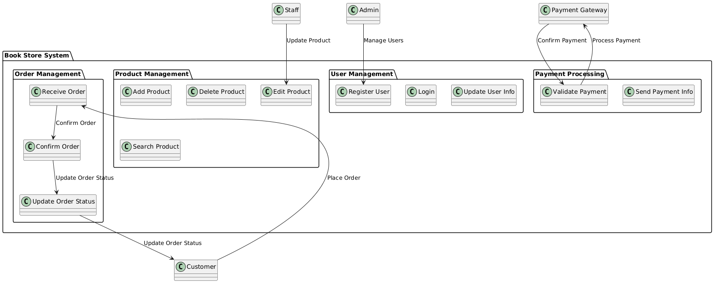

**Key Components:**

* Order Management: Includes functions such as receiving orders, confirming them, and updating order statuses.
* Product Management: Encompasses operations like adding, editing, deleting, and searching for products.
* User Management: Focuses on registration, login, and updating user information.
* Payment Processing: Responsible for validating and sending payment information to the payment gateway.

**Data Flows:**

* Customers send order requests to the Order Receiving function.
* The system processes the order and updates the status, providing feedback on the order's condition to the customer.

Staff and Admin perform management operations for products and users.

## Feature Tree

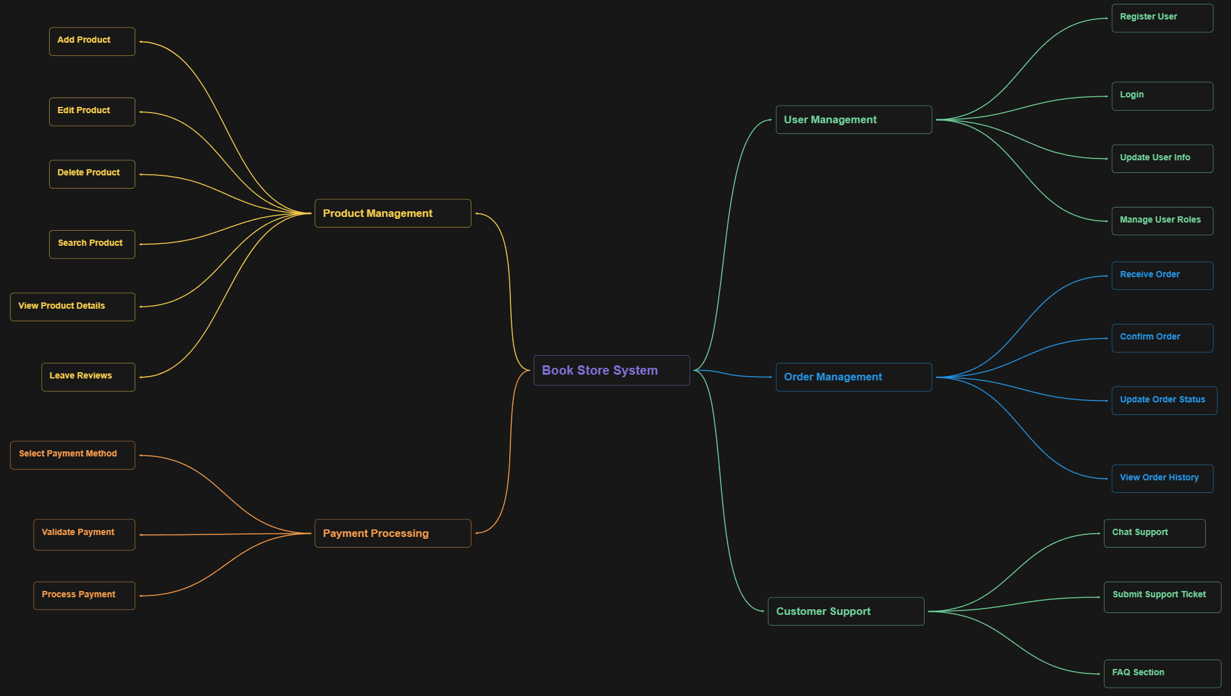

* 1. ***User Management***
* Register User: This feature allows new customers to create an account in the system, providing their personal details for registration.
* Login: Registered users can log in to their accounts using their credentials to access various functionalities of the system.
* Update User Info: Users have the capability to edit and update their personal information, ensuring their profiles remain current.
* Manage User Roles: Admin users can assign or modify user roles (e.g., admin, staff, customer) to control access and permissions within the system.
  1. ***Product Management***
* Add Product: Admins can add new books to the inventory, including details such as title, author, category, price, and quantity.
* Edit Product: This feature allows admins to modify existing product information to keep it up-to-date.
* Delete Product: Admins can remove books from the inventory when necessary, such as when they are out of stock or discontinued.
* Search Product: Customers can search for books by various criteria, such as title, author, or category, to find desired products.
* View Product Details: Users can view detailed information about a selected book, including descriptions, reviews, and availability.
* Leave Reviews: Customers can submit reviews and ratings for books they have purchased, helping others in their decision-making process.
  1. ***Order Management***
* Receive Order: The system captures and processes orders placed by customers.
* Confirm Order: Staff members confirm the receipt of orders, ensuring that they are processed correctly.
* Update Order Status: The status of each order is updated in the system, keeping customers informed about their order progress.
* View Order History: Customers can view their past orders, including details about items purchased and order statuses.
  1. ***Payment Processing***
* Select Payment Method: Customers can choose their preferred payment option from various methods available, such as credit cards, e-wallets, or cash on delivery (COD).
* Validate Payment: This functionality ensures that the payment details provided by the user are accurate and valid before processing.
* Process Payment: The system handles the transaction process, securely processing payments and confirming successful transactions.
  1. ***Customer Support***
* Chat Support: Customers have access to real-time chat support to communicate with staff for assistance or inquiries.
* Submit Support Ticket: Users can submit requests for support or issues they encounter through a ticketing system.
* FAQ Section: A frequently asked questions section is available to help customers find answers to common queries without needing direct support.

## State Transition Diagram

### Order Management

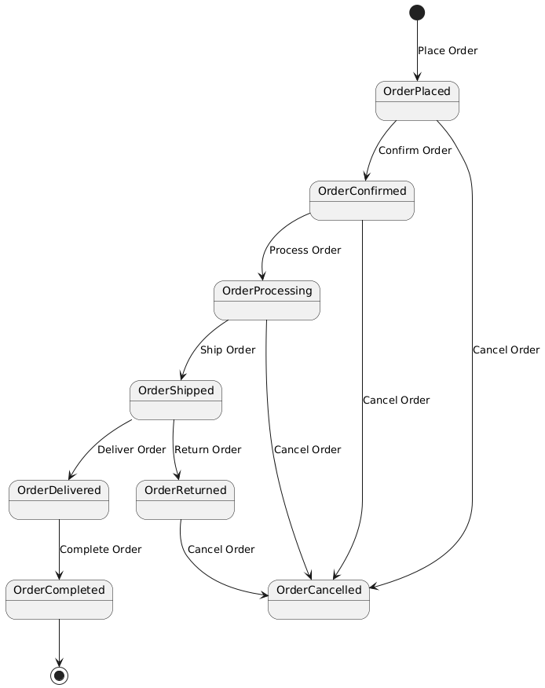

* **OrderPlaced**: The initial state after a customer places an order.
* **OrderConfirmed**: The state where the order has been confirmed by the staff.
* **OrderProcessing**: The state during which the order is being processed.
* **OrderShipped**: The order has been shipped to the customer.
* **OrderDelivered**: The order has been delivered to the customer.
* **OrderCompleted**: The final state indicating that the order process is complete.
* **OrderCancelled**: A state indicating that the order has been cancelled at any point.

### User Management

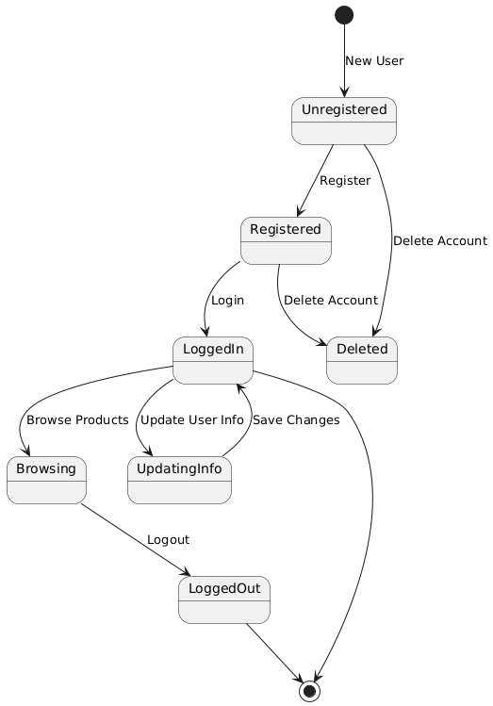

* **Unregistered**: The initial state for new users who have not registered yet.
* **Registered**: The state where the user has successfully registered but is not yet logged in.
* **LoggedIn**: The state where the user is logged into their account.
* **Browsing**: The state where the logged-in user browses products.
* **LoggedOut**: The state when the user has logged out.
* **UpdatingInfo**: The state during which the user updates their account information.
* **Deleted**: A state indicating that the user's account has been deleted.

## Entity Relationship Diagrams (ERD)

